UNITED STATES
SECURITIES AND EXCHANGE COMMISSION
Washington, D.C. 20549

FORM 6-K

REPORT OF FOREIGN PRIVATE ISSUER PURSUANT TO RULE 13a-16 OR 15d-16 UNDER
THE SECURITIES EXCHANGE ACT OF 1934

October 23, 2026

Commission File Number: 001-39363

IMMATICS N.V.

Paul-Ehrlich-Straße 15
72076 Tübingen, Federal Republic of Germany
(Address of principal executive office)

Indicate by check mark whether the registrant files or will file annual reports under cover of Form 20-F or Form 40-F:

Form 20-F | ☒ |  | Form 40-F | ☐

INFORMATION CONTAINED IN THIS REPORT ON FORM 6-K

IMA203CD8 Data Release

On October 23, 2026, Immatics N.V. (the “Company” or “Immatics”) announced updated Phase 1 data for its IMA203CD8 PRAME TCR T-cell therapy across multiple solid tumor types.

Patient Population. As of August 7, 2026 data cutoff, 98 heavily pretreated patients across multiple advanced solid tumor types expressing PRAME that had undergone a median of 3 prior systemic treatments were enrolled in the ongoing Phase 1 dose escalation/dose expansion trial. Of these, 90 patients were evaluable for efficacy, including 27 with gynecologic cancers (ovarian and uterine cancer), 44 with melanoma, 12 with synovial sarcoma and 7 with other solid tumor types. The median dose for the safety population was 1.81x109 TCR T cells (range 0.44-12.50×109). The median total infused dose across seven escalating dose levels was 3.55×109 TCR T cells (range 0.47×109 – 12.50×109) for gynecologic cancers, 1.67×109 TCR T cells (range 0.44×109 – 11.80×109) for melanoma, 1.59×109 TCR T cells (range 0.89×109 – 10.00×109) for synovial sarcoma, and 1.95×109 TCR T cells (range 1.47×109 – 10.00×109) for other solid tumor types. All patients were heavily pretreated, and all 24 patients with ovarian cancer had received prior platinum-based therapy. Patients with gynecologic cancers had a median of four prior lines of systemic treatment (range 1 – 7), patients with melanoma had a median of three prior lines (range 0 – 9), patients with synovial sarcoma had a median of two prior lines (range 1 – 5) and patients with other solid tumor types had a median of four prior lines (range 2 – 7). Of the 90 efficacy-evaluable patients, patients with gynecologic cancers were the largest subgroup treated at clinically relevant doses (≥DL4c).

Safety Data. IMA203CD8 demonstrated a consistent and manageable safety profile across different solid tumor types and a wide dose range (median dose 1.81x109 TCR T cells, range 0.44-12.50x109). The most frequent treatment-emergent adverse events (“TEAEs”) were expected and included transient cytopenias associated with the lymphodepletion regimen and low-grade cytokine release syndrome (“CRS”), consistent with the mechanism of action. Immune effector cell-associated neurotoxicity syndrome (“ICANS”) was infrequently observed, and no IMA203CD8-related Grade 5 events occurred. Maximum tolerated dose (“MTD”) was not reached with doses up to 12.5 billion IMA203CD8 cells.

The following table shows TEAEs occurring in 20% or more of patients:

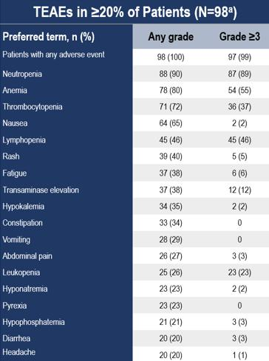

a All patients who started lymphodepletion, including 1 patient who did not receive IMA203CD8 cells

Anti-Tumor Activity and Durability. A one-time infusion of IMA203CD8 PRAME cell therapy showed anti-tumor activity across multiple tumor types for all evaluated dose levels, including lower dose levels not selected for further clinical development:

 | • | Objective response rate (“ORR”) was 51% (46/90) and confirmed ORR (“cORR”) was 41% (36/87)

 | o | Durable long-term responses were observed with ongoing responses for more than 2.5 years

 | • | Tumor reduction was observed in 83% (71/86) of patients with evaluable target lesions

 | • | Disease Control Rate (“DCR”) at week 6 was 82% (74/90)

The graphic below sets forth the observed anti-tumor activity across all evaluated dose levels and tumor types, including lower dose levels not selected for further clinical development.

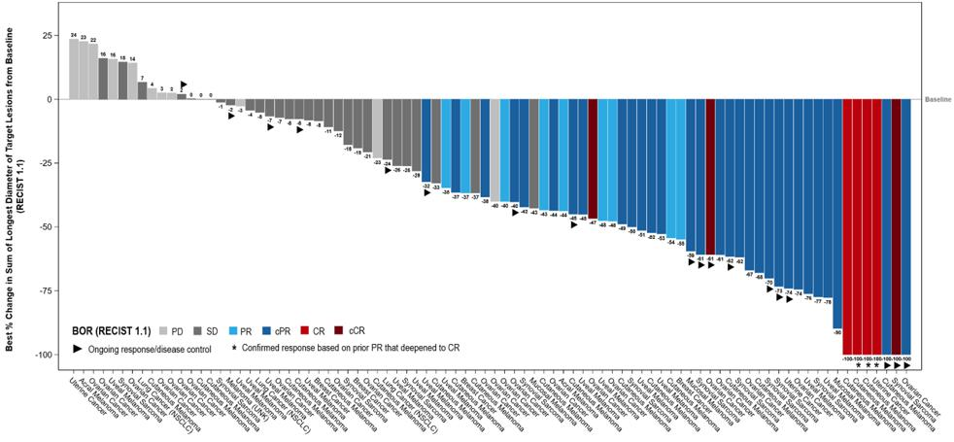

3 patients without any post-baseline scan not evaluable for assessment of tumor reduction, not depicted in the plot, but included in efficacy calculations; For those patients who achieved a (c)CR with <100% change from baseline, target lesions were lymph nodes that resolved to <10 mm per RECIST 1.1. BOR, best overall response; (c)CR, (confirmed) complete response; NSCLC, non-small cell lung cancer; PD, progressive disease; (c)PR, (confirmed) partial response; SD, stable disease.

In 20 patients with gynecologic cancers (ovarian and uterine cancer) treated at clinically relevant dose levels (≥DL4c), IMA203CD8 demonstrated consistent anti-tumor activity with an ORR of 60% (12/20) and a cORR of 55% (11/20), a DCR of 70% (14/20) and tumor reduction in 68% (13/19) of patients. Early durability data showed a median duration of response (“mDOR”) of 8.4 months, with a median follow-up time (“mFU”) of 6.0 months, a median progression free survival (“mPFS”) of 5.8 months (mFU 8.1 months) and median overall survival (“mOS”) not reached at 7.8 months mFU.

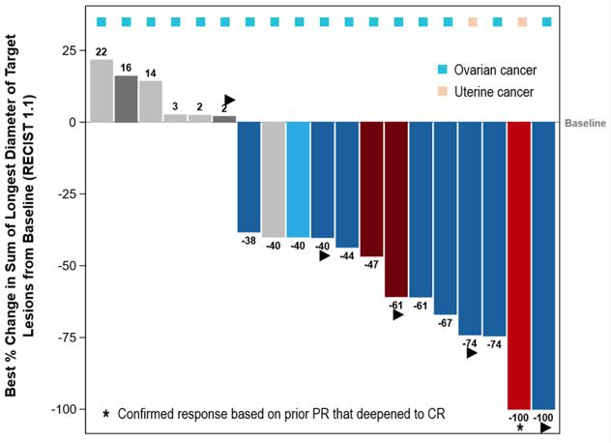

1 patient without any post-baseline scan not evaluable for assessment of tumor reduction, not depicted in plot, but included in efficacy calculations; those patients achieving a (c)CR with <100% changes from baseline, target lesions were lymph nodes that resolved to <10 mm per RECIST 1.1; BOR, best overall response; (c)CR, (confirmed) complete response; PD, progressive disease; (c)PR, (confirmed) partial response; SD, stable disease.

Next Development Steps

Phase 1a dose escalation is complete. Immatics is currently enrolling patients with uterine cancer at clinically relevant doses to further expand the clinical dataset in this indication. In addition, a Phase 1/2 investigator-initiated trial (“IIT”) in patients with PRAME-positive pediatric cancers is planned to start in 1H 2027. The clinical activity of IMA203CD8 observed across tumor types with distinct biology and differing levels of PRAME expression, including ovarian cancer, uterine cancer, melanoma and synovial sarcoma, supports the broad applicability of IMA203CD8 across PRAME-positive cancers. The development approach for IMA203CD8 will leverage targeted cohorts of selected tumor types, such as ovarian cancer, uterine cancer, rare cancers and pediatric cancers to build the clinical evidence base for broader, tumor-agnostic application.

* * *

Certain statements in this report may be considered forward-looking statements. Forward-looking statements generally relate to future events or the Company’s future financial or operating performance. For example, statements concerning timing of data read-outs for product candidates, the timing, outcome and design of clinical trials, the nature of clinical trials (including whether such clinical trials will be registration-enabling), the timing and outcomes of IND, CTA, BLA and other regulatory filings, or the timing of commercial launches, estimated market opportunities of product candidates, manufacturing timetables, capacity and success rates, the potential benefits of product candidates, the Company’s focus on partnerships to advance its intended strategy, and other metrics are forward-looking statements. In some cases, you can identify forward-looking statements by terminology such as “may”, “should”, “expect”, “plan”, “target”, “intend”, “will”, “estimate”, “anticipate”, “believe”, “predict”, “potential” or “continue”, or the negatives of these terms or variations of them or similar terminology. Such forward-looking statements are subject to risks, uncertainties, and other factors which could cause actual results to differ materially from those expressed or implied by such forward-looking statements. These forward-looking statements are based upon estimates and assumptions that, while considered reasonable by Immatics and its management, are inherently uncertain. New risks and uncertainties may emerge from time to time, and it is not possible to predict all risks and uncertainties. Factors that may cause actual results to differ materially from current expectations include, but are not limited to, various factors beyond management's control including general economic conditions and other risks, uncertainties and factors set forth in the Company’s Annual Report on Form 20-F and other filings with the Securities and Exchange Commission (SEC). Nothing in this report should be regarded as a representation by any person that the forward-looking statements set forth herein will be achieved or that any of the contemplated results of such forward-looking statements will be achieved. You should not place undue reliance on forward-looking statements, which speak only as of the date they are made. The Company undertakes no duty to update these forward-looking statements. All the scientific and clinical data presented within this report are – by definition prior to completion of the clinical trial and a clinical study report – preliminary in nature and subject to further quality checks including customary source data verification.

* * *

In connection with the foregoing, the Company made available a presentation, a copy of which is attached hereto as Exhibit 99.1.

INCORPORATION BY REFERENCE

This Report on Form 6-K (other than the exhibits hereto) shall be deemed to be incorporated by reference into the registration statements on Form F-3 (Registration Nos. 333-240260, 333-274218 and 333-286151) of Immatics N.V. and to be a part thereof from the date on which this report is filed, to the extent not superseded by documents or reports subsequently filed or furnished.

EXHIBIT INDEX

Exhibit No. | Description
99.1 | Targeting PRAME+ Tumors with IMA203CD8, a PRAME-directed TCR T-cell Therapy: Results from a Phase 1 Study

SIGNATURES

Pursuant to the requirements of the Securities Exchange Act of 1934, the registrant has duly caused this report to be signed on its behalf by the undersigned, thereunto duly authorized.

 | IMMATICS N.V.
Date: October 23, 2026
 | By: | /s/ Harpreet Singh
 | Name: | Harpreet Singh
 | Title: | Chief Executive Officer

Exhibit 99.1

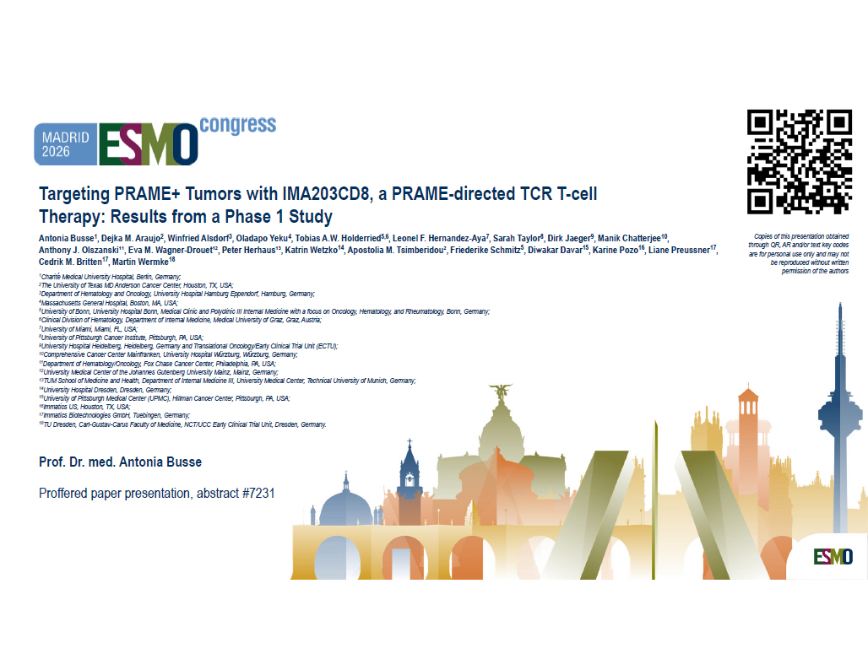
Targeting PRAME+ Tumors with IMA203CD8, a PRAME - directed TCR T - cell Therapy: Results from a Phase 1 Study Antonia Busse 1 , Dejka M. Araujo 2 , Winfried Alsdorf 3 , Oladapo Yeku 4 , Tobias A.W. Holderried 5,6 , Leonel F. Hernandez - Aya 7 , Sarah Taylor 8 , Dirk Jaeger 9 , Manik Chatterjee 10 , Anthony J. Olszanski¹¹, Eva M. Wagner - Drouet¹², Peter Herhaus¹³, Katrin Wetzko 14 , Apostolia M. Tsimberidou², Friederike Schmitz 5 , Diwakar Davar 15 , Karine Pozo 16 , Liane Preussner 17 , Cedrik M. Britten 17 , Martin Wermke 18 Prof. Dr. med. Antonia Busse Proffered paper presentation , abstract #7231 1 Charité Medical University Hospital, Berlin, Germany; 2 The University of Texas MD Anderson Cancer Center, Houston, TX, USA; 3 Department of Hematology and Oncology , University Hospital Hamburg Eppendorf, Hamburg, Germany; 4 Massachusetts General Hospital, Boston, MA, USA; 5 University of Bonn, University Hospital Bonn, Medical Clinic and Polyclinic III Internal Medicine with a focus on Oncology , Hematology , and Rheumatology , Bonn, Germany; 6 Clinical Division of Hematology , Department of Internal Medicine, Medical University of Graz, Graz, Austria; 7 University of Miami, Miami, FL, USA; 8 University of Pittsburgh Cancer Institute, Pittsburgh, PA, USA; 9 University Hospital Heidelberg, Heidelberg, Germany and Translational Oncology /Early Clinical Trial Unit (ECTU); 10 Comprehensive Cancer Center Mainfranken, University Hospital Würzburg, Würzburg, Germany; 11 Department of Hematology / Oncology , Fox Chase Cancer Center, Philadelphia, PA, USA; 12 University Medical Center of the Johannes Gutenberg University Mainz, Mainz, Germany; 13 TUM School of Medicine and Health, Department of Internal Medicine III, University Medical Center, Technical University of Munich, Germany; 14 University Hospital Dresden, Dresden, Germany; 15 University of Pittsburgh Medical Center (UPMC), Hillman Cancer Center, Pittsburgh, PA, USA; 16 Immatics US, Houston, TX, USA; 17 Immatics Biotechnologies GmbH, Tuebingen , Germany; 18 TU Dresden, Carl - Gustav - Carus Faculty of Medicine, NCT/UCC Early Clinical Trial Unit, Dresden, Germany. Copies of this presentation obtained through QR, AR and/or text key codes are for personal use only and may not be reproduced without written permission of the authors

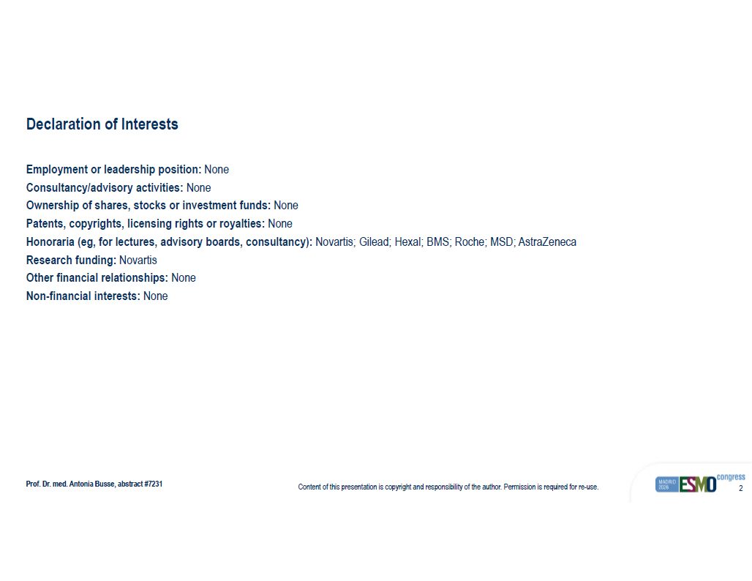
Content of this presentation is copyright and responsibility of the author. Permission is required for re - use. 2 Declaration of Interests Prof. Dr. med. Antonia Busse , abstract #7231 Employment or leadership position: None Consultancy/advisory activities: None Ownership of shares, stocks or investment funds: None Patents, copyrights, licensing rights or royalties: None Honoraria ( eg , for lectures, advisory boards, consultancy): Novartis; Gilead; Hexal ; BMS; Roche; MSD; AstraZeneca Research funding: Novartis Other financial relationships: None Non - financial interests: None

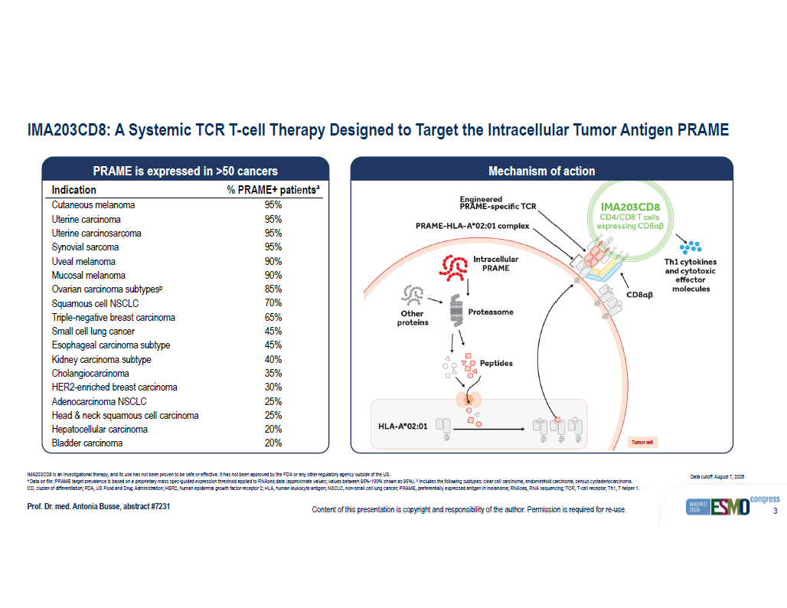
Content of this presentation is copyright and responsibility of the author. Permission is required for re - use. 3 IMA203CD8: A Systemic TCR T - cell Therapy Designed to Target the Intracellular Tumor Antigen PRAME Prof. Dr. med. Antonia Busse , abstract #7231 IMA203CD8 is an investigational therapy, and its use has not been proven to be safe or effective. It has not been approved by th e FDA or any other regulatory agency outside of the US. a Data on file: PRAME target prevalence is based on a proprietary mass spec - guided expression threshold applied to RNAseq data (approximate values; values between 95% - 100% shown as 95%). b Includes the following subtypes: clear cell carcinoma, endometrioid carcinoma, serous cystadenocarcinoma. CD, cluster of differentiation; FDA, US Food and Drug Administration; HER2, human epidermal growth factor receptor 2; HLA, hu man leukocyte antigen; NSCLC, non - small cell lung cancer; PRAME, preferentially expressed antigen in melanoma; RNAseq , RNA sequencing; TCR, T - cell receptor; Th1, T helper 1. Data cutoff: August 7, 2026 % PRAME+ patients a Indication 95% Cutaneous melanoma 95% Uterine carcinoma 95% Uterine carcinosarcoma 95% Synovial sarcoma 90% Uveal melanoma 90% Mucosal melanoma 85% Ovarian carcinoma subtypes b 70% Squamous cell NSCLC 65% Triple - negative breast carcinoma 45% Small cell lung cancer 45% Esophageal carcinoma subtype 40% Kidney carcinoma subtype 35% Cholangiocarcinoma 30% HER2 - enriched breast carcinoma 25% Adenocarcinoma NSCLC 25% Head & neck squamous cell carcinoma 20% Hepatocellular carcinoma 20% Bladder carcinoma PRAME is expressed in >50 cancers Mechanism of action Tumor cell

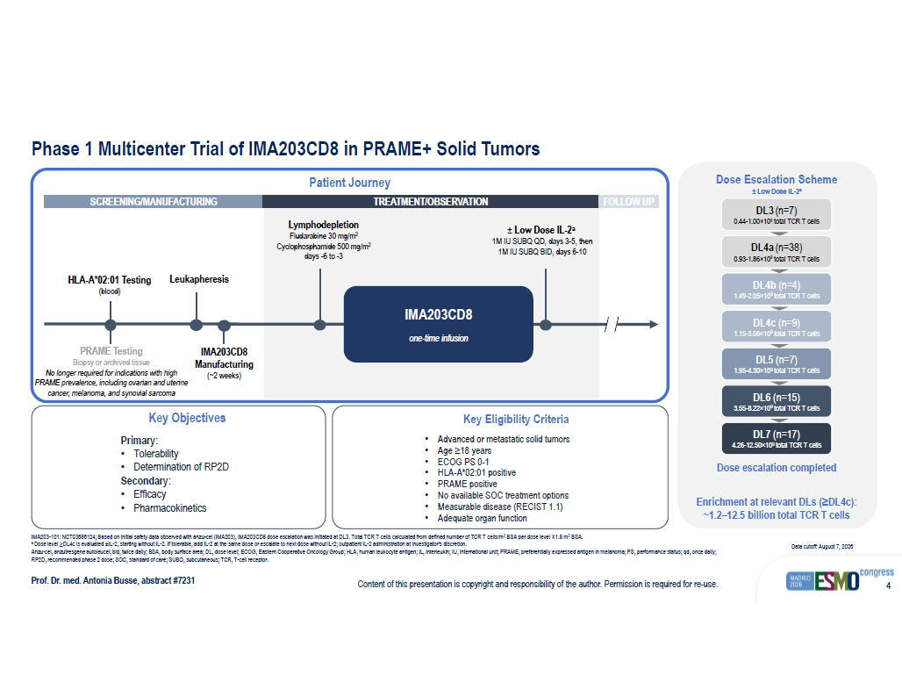
Content of this presentation is copyright and responsibility of the author. Permission is required for re - use. 4 Phase 1 Multicenter Trial of IMA203CD8 in PRAME+ Solid Tumors Prof. Dr. med. Antonia Busse , abstract #7231 IMA203 - 101: NCT03686124; Based on initial safety data observed with anzu - cel (IMA203), IMA203CD8 dose escalation was initiated at DL3. Total TCR T cells calculated from defined number of TCR T cells /m 2 BSA per dose level î 1.8 m 2 BSA. a Dose level ≥DL4c is evaluated  IL - 2, starting without IL - 2. If tolerable, add IL - 2 at the same dose or escalate to next dose without IL - 2; outpatient IL - 2 admi nistration at investigator’s discretion. Anzu - cel, anzutresgene autoleucel; bid, twice daily; BSA, body surface area; DL, dose level; ECOG, Eastern Cooperative Oncology Group; HLA, human le uk ocyte antigen; IL, interleukin; IU, international unit; PRAME, preferentially expressed antigen in melanoma; PS, performance sta tus; qd , once daily; RP2D, recommended phase 2 dose; SOC, standard of care; SUBQ, subcutaneous; TCR, T - cell receptor. Data cutoff: August 7, 2026 PRAME Testing Biopsy or archived tissue No longer required for indications with high PRAME prevalence, including ovarian and uterine cancer, melanoma, and synovial sarcoma IMA203CD8 Manufacturing (~2 weeks) Lymphodepletion Fludarabine 30 mg/m 2 Cyclophosphamide 500 mg/m 2 days - 6 to - 3 ц Low Dose IL - 2 a 1M IU SUBQ QD, days 3 - 5, then 1M IU SUBQ BID, days 6 - 10 Leukapheresis HLA - A*02:01 Testing (blood) Patient Journey SCREENING/MANUFACTURING TREATMENT/OBSERVATION FOLLOW UP IMA203CD8 one - time infusion Dose escalation completed Enrichment at relevant DLs (≥DL4c): ~1.2 – 12.5 billion total TCR T cells DL3 (n=7) 0.44 - 1.00 × 10 9 total TCR T cells DL4a (n=38) 0.93 - 1.86 × 10 9 total TCR T cells DL4b (n=4) 1.49 - 2.05 п 10 9 total TCR T cells DL5 (n=7) 1.95 - 4.30 п 10 9 total TCR T cells DL6 (n=15) 3.55 - 8.22 п 10 9 total TCR T cells DL7 (n=17) 4.26 - 12.50 × 10 9 total TCR T cells Dose Escalation Scheme ц Low Dose IL - 2 a Key Objectives Primary: • Tolerability • Determination of RP2D Secondary: • Efficacy • Pharmacokinetics Key Eligibility Criteria • Advanced or metastatic solid tumors • Age ≥ 18 years • ECOG PS 0 - 1 • HLA - A*02:01 positive • PRAME positive • No available SOC treatment options • Measurable disease (RECIST 1.1) • Adequate organ function DL4c (n=9) 1.15 - 3.06 п 10 9 total TCR T cells

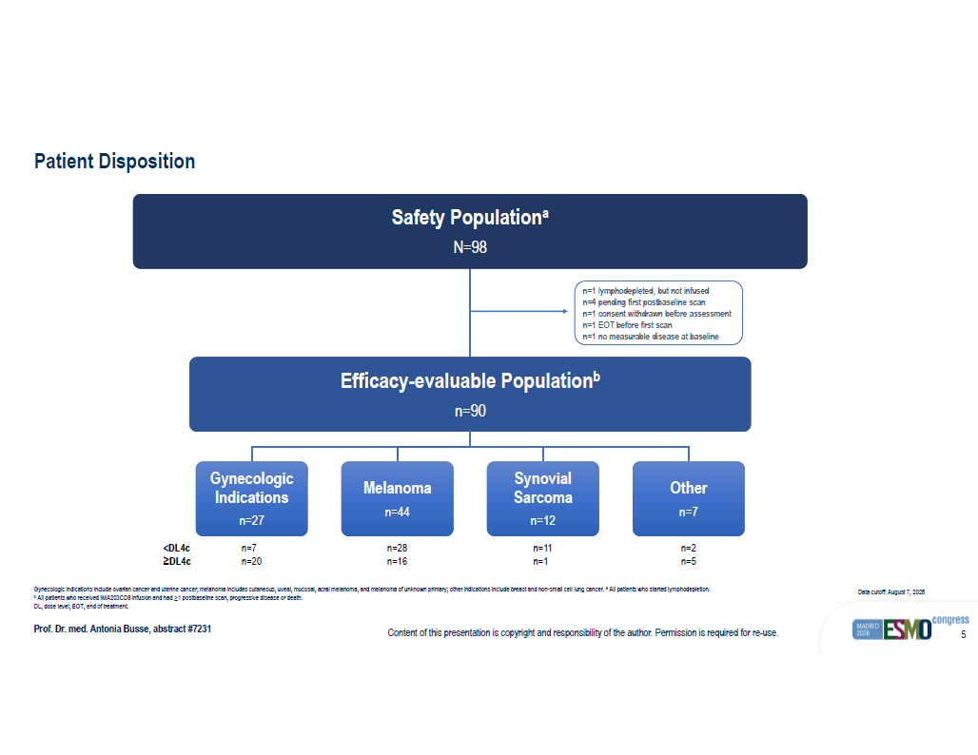
Content of this presentation is copyright and responsibility of the author. Permission is required for re - use. 5 Patient Disposition Prof. Dr. med. Antonia Busse , abstract #7231 Gynecologic indications include ovarian cancer and uterine cancer ; melanoma includes cutaneous , uveal , mucosal , acral melanoma , and melanoma of unknown primary ; other indications include breast and non - small cell lung cancer . a All patients who started lymphodepletion . b All patients who received IMA203CD8 infusion and had ≥1 postbaseline scan, progressive disease or death. DL, dose level; EOT, end of treatment. Data cutoff: August 7, 2026 Safety Population a N=98 Efficacy - evaluable Population b n=90 Gynecologic Indications n=27 Melanoma n=44 Synovial Sarcoma n=12 Other n=7 n=1 lymphodepleted, but not infused n=4 pending first postbaseline scan n=1 consent withdrawn before assessment n=1 EOT before first scan n=1 no measurable disease at baseline n=7 n=20 n=28 n=16 n=11 n=1 n=2 n=5 <DL4c ≥DL4c

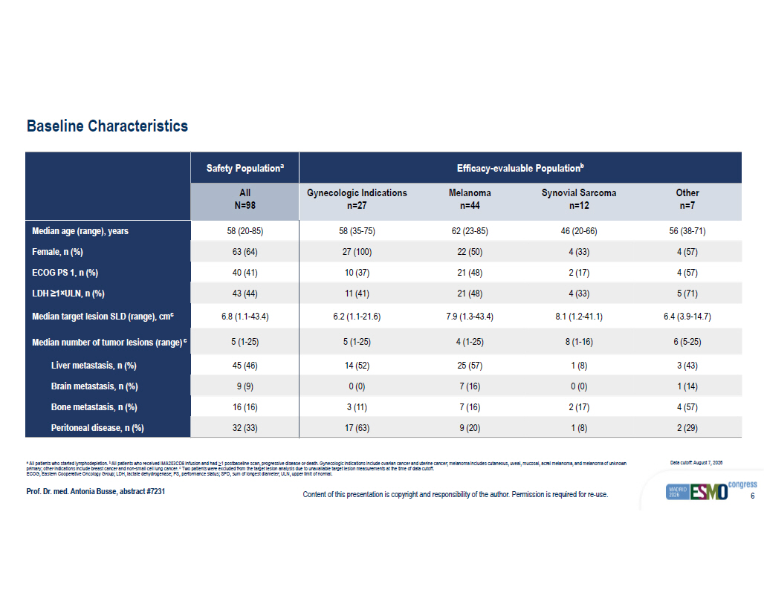
Content of this presentation is copyright and responsibility of the author. Permission is required for re - use. 6 Baseline Characteristics Prof. Dr. med. Antonia Busse , abstract #7231 a All patients who started lymphodepletion. b All patients who received IMA203CD8 infusion and had ≥1 postbaseline scan, progressive disease or death. Gynecologic indications include ovarian cancer and uterine cancer ; melanoma includes cutaneous , uveal , mucosal , acral melanoma , and melanoma of unknown primary ; other indications include breast cancer and non - small cell lung cancer . c Two patients were excluded from the target lesion analysis due to unavailable target lesion measurements at the time of data cut off. ECOG, Eastern Cooperative Oncology Group; LDH, lactate dehydrogenase; PS, performance status; SPD, sum of longest diameter; U LN, upper limit of normal. Data cutoff: August 7, 2026 Efficacy - evaluable Population b Safety Population a Other n=7 Synovial Sarcoma n=12 Melanoma n=44 Gynecologic Indications n=27 All N=98 56 (38 - 71) 46 (20 - 66) 62 (23 - 85) 58 (35 - 75) 58 (20 - 85) Median age (range), years 4 (57) 4 (33) 22 (50) 27 (100) 63 (64) Female, n (%) 4 (57) 2 (17) 21 (48) 10 (37) 40 (41) ECOG PS 1, n (%) 5 (71) 4 (33) 21 (48) 11 (41) 43 (44) LDH ≥1 × ULN, n (%) 6.4 (3.9 - 14.7) 8.1 (1.2 - 41.1) 7.9 (1.3 - 43.4) 6.2 (1.1 - 21.6) 6.8 (1.1 - 43.4) Median target lesion SLD (range), cm c 6 (5 - 25) 8 (1 - 16) 4 (1 - 25) 5 (1 - 25) 5 (1 - 25) Median number of tumor lesions (range) c 3 (43) 1 (8) 25 (57) 14 (52) 45 (46) Liver metastasis, n (%) 1 (14) 0 (0) 7 (16) 0 (0) 9 (9) Brain metastasis, n (%) 4 (57) 2 (17) 7 (16) 3 (11) 16 (16) Bone metastasis, n (%) 2 (29) 1 (8) 9 (20) 17 (63) 32 (33) Peritoneal disease, n (%)

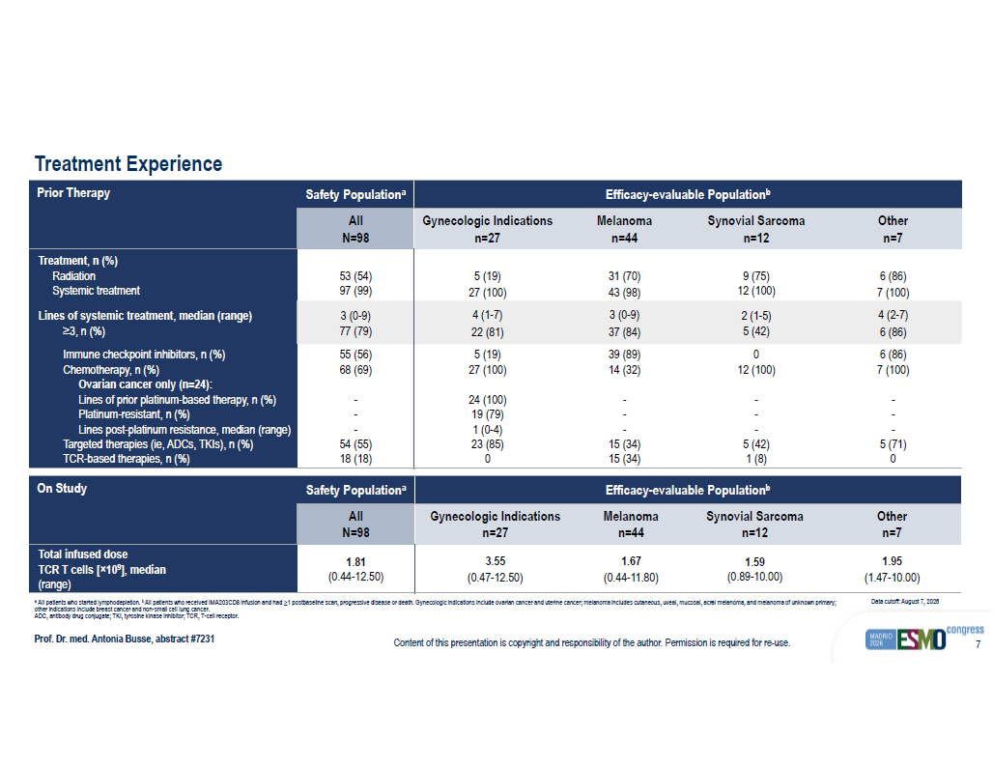
Content of this presentation is copyright and responsibility of the author. Permission is required for re - use. 7 Treatment Experience Prof. Dr. med. Antonia Busse , abstract #7231 Efficacy - evaluable Population b Safety Population a On Study Other n=7 Synovial Sarcoma n=12 Melanoma n=44 Gynecologic Indications n=27 All N=98 1.95 (1.47 - 10.00) 1.59 (0.89 - 10.00) 1.67 (0.44 - 11.80) 3.55 (0.47 - 12.50) 1.81 (0.44 - 12.50) Total infused dose TCR T cells [ × 10 9 ], median (range) Efficacy - evaluable Population b Safety Population a Prior Therapy Other n=7 Synovial Sarcoma n=12 Melanoma n=44 Gynecologic Indications n=27 All N=98 6 (86) 7 (100) 9 (75) 12 (100) 31 (70) 43 (98) 5 (19) 27 (100) 53 (54) 97 (99) Treatment, n (%) Radiation Systemic treatment 4 (2 - 7) 6 (86) 2 (1 - 5) 5 (42) 3 (0 - 9) 37 (84) 4 (1 - 7) 22 (81) 3 (0 - 9) 77 (79) Lines of systemic treatment, median (range) ≥3, n (%) 6 (86) 7 (100) - - - 5 (71) 0 0 12 (100) - - - 5 (42) 1 (8) 39 (89) 14 (32) - - - 15 (34) 15 (34) 5 (19) 27 (100) 24 (100) 19 (79) 1 (0 - 4) 23 (85) 0 55 (56) 68 (69) - - - 54 (55) 18 (18) Immune checkpoint inhibitors, n (%) Chemotherapy, n (%) Ovarian cancer only (n=24): Lines of prior platinum - based therapy, n (%) Platinum - resistant, n (%) Lines post - platinum resistance, median (range) Targeted therapies ( ie , ADCs, TKIs), n (%) TCR - based therapies, n (%) a All patients who started lymphodepletion. b All patients who received IMA203CD8 infusion and had ≥1 postbaseline scan, progressive disease or death. Gynecologic indications include ovarian cancer and uterine cancer ; melanoma includes cutaneous , uveal , mucosal , acral melanoma , and melanoma of unknown primary ; other indications include breast cancer and non - small cell lung cancer . ADC, antibody drug conjugate; TKI, tyrosine kinase inhibitor; TCR, T - cell receptor. Data cutoff: August 7, 2026

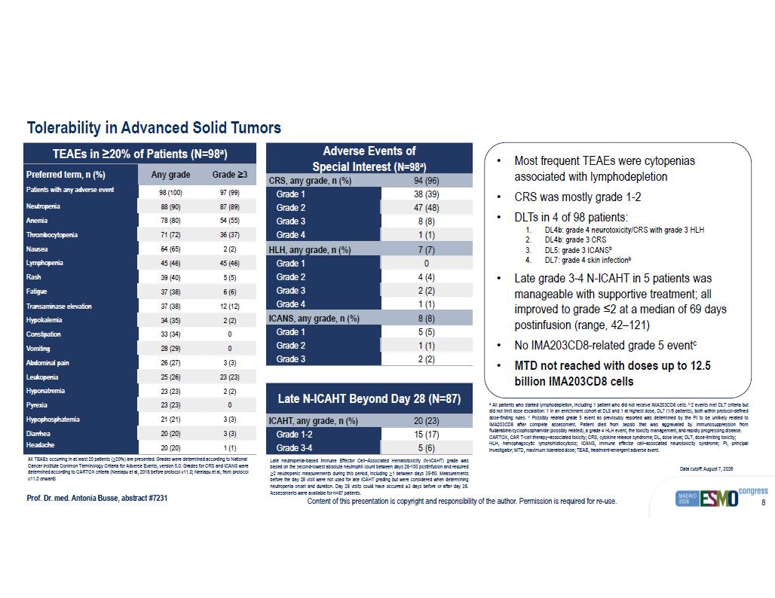
Content of this presentation is copyright and responsibility of the author. Permission is required for re - use. 8 Tolerability in Advanced Solid Tumors Prof. Dr. med. Antonia Busse , abstract #7231 a All patients who started lymphodepletion, including 1 patient who did not receive IMA 203 CD 8 cells . b 2 events met DLT criteria but did not limit dose escalation : 1 in an enrichment cohort at DL 5 and 1 at highest dose, DL 7 ( 1 / 6 patients), both within protocol - defined dose - finding rules . c Possibly related grade 5 event as previously reported was determined by the PI to be unlikely related to IMA 203 CD 8 after complete assessment . Patient died from sepsis that was aggravated by immunosuppression from fludarabine/cyclophosphamide (possibly related), a grade 4 HLH event, the toxicity management, and rapidly progressing disease . CARTOX, CAR T - cell therapy – associated toxicity ; CRS, cytokine release syndrome ; DL, dose level ; DLT, dose - limiting toxicity ; HLH, hemophagocytic lymphohistiocytosis ; ICANS, immune effector cell – associated neurotoxicity syndrome ; PI, principal investigator ; MTD, maximum tolerated dose ; TEAE, treatment - emergent adverse event . Data cutoff: August 7, 2026 • Most frequent TEAEs were cytopenias associated with lymphodepletion • CRS was mostly grade 1 - 2 • DLTs in 4 of 98 patients: 1. DL4b: grade 4 neurotoxicity/CRS with grade 3 HLH 2. DL4b: grade 3 CRS 3. DL5: grade 3 ICANS b 4. DL7: grade 4 skin infection b • Late grade 3 - 4 N - ICAHT in 5 patients was manageable with supportive treatment ; all improved to grade ≤2 at a median of 69 days postinfusion (range, 42 – 121) • No IMA203CD8 - related grade 5 event c • MTD not reached with doses up to 12.5 billion IMA203CD8 cells TEAEs in ≥20% of Patients ( N=98 a ) Grade ≥3 Any grade Preferred term, n (%) 97 (99) 98 (100) Patients with any adverse event 87 (89) 88 (90) Neutropenia 54 (55) 78 (80) Anemia 36 (37) 71 (72) Thrombocytopenia 2 (2) 64 (65) Nausea 45 (46) 45 (46) Lymphopenia 5 (5) 39 (40) Rash 6 (6) 37 (38) Fatigue 12 (12) 37 (38) Transaminase elevation 2 (2) 34 (35) Hypokalemia 0 33 (34) Constipation 0 28 (29) Vomiting 3 (3) 26 (27) Abdominal pain 23 (23) 25 (26) Leukopenia 2 (2) 23 (23) Hyponatremia 0 23 (23) Pyrexia 3 (3) 21 (21) Hypophosphatemia 3 (3) 20 (20) Diarrhea 1 (1) 20 (20) Headache Adverse Events of Special Interest ( N=98 a ) 94 (96) CRS, any grade, n (%) 38 (39) Grade 1 47 (48) Grade 2 8 (8) Grade 3 1 (1) Grade 4 7 (7) HLH, any grade, n (%) 0 Grade 1 4 (4) Grade 2 2 (2) Grade 3 1 (1) Grade 4 8 (8) ICANS, any grade, n (%) 5 (5) Grade 1 1 (1) Grade 2 2 (2) Grade 3 Late N - ICAHT Beyond Day 28 ( N=87) 20 (23) ICAHT, any grade, n (%) 15 (17) Grade 1 - 2 5 (6) Grade 3 - 4 All TEAEs occurring in at least 20 patients ( ≥20%) are presented. Grades were determined according to National Cancer Institute Common Terminology Criteria for Adverse Events, version 5.0. Grades for CRS and ICANS were determined according to CARTOX criteria ( Neelapu et al, 2018 before protocol v11.0; Neelapu et al, from protocol v11.0 onward ) Late neutropenia - based Immune Effector Cell – Associated Hematotoxicity (N - ICAHT) grade was based on the second - lowest absolute neutrophil count between days 28 - 100 postinfusion and required ≥ 2 neutropenic measurements during this period , including ≥ 1 between days 35 - 60 . Measurements before the day 28 visit were not used for late ICAHT grading but were considered when determining neutropenia onset and duration . Day 28 visits could have occurred ± 3 days before or after day 28 . Assessments were available for n= 87 patients .

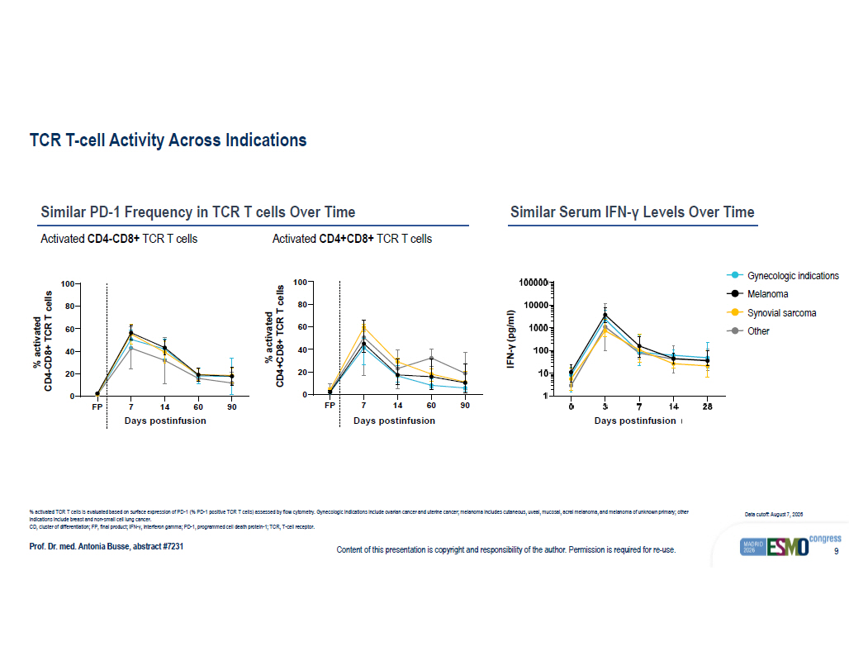
Content of this presentation is copyright and responsibility of the author. Permission is required for re - use. 9 TCR T - cell Activity Across Indications Prof. Dr. med. Antonia Busse , abstract #7231 % activated TCR T cells is evaluated based on surface expression of PD - 1 (% PD - 1 positive TCR T cells ) assessed by flow cytometry . Gynecologic indications include ovarian cancer and uterine cancer ; melanoma includes cutaneous , uveal , mucosal , acral melanoma , and melanoma of unknown primary ; other indications include breast and non - small cell lung cancer. CD, cluster of differentiation ; FP, final product ; IFN - γ, interferon gamma ; PD - 1, programmed cell death protein - 1; TCR, T - cell receptor . Data cutoff: August 7, 2026 Similar PD - 1 Frequency in TCR T cells Over Time Similar Serum IFN - γ Levels Over Time Activated CD4 - CD8+ TCR T cells Activated CD4+CD8+ TCR T cells FP 7 14 60 90 0 20 40 60 80 100 PD-1 Days post-infusion % a c t i v a t e d C D 4 - C D 8 + T C R - T Melanoma SynSar GynOnc Others % activated CD4 - CD8+ TCR T cells FP 7 14 60 90 0 20 40 60 80 100 PD-1 Days post-infusion % a c t i v a t e d C D 4 + C D 8 + T C R - T Melanoma SynSar GynOnc Others % activated CD4+CD8+ TCR T cells Days postinfusion Days postinfusion Days postinfusion Melanoma Synovial sarcoma Other Gynecologic indications

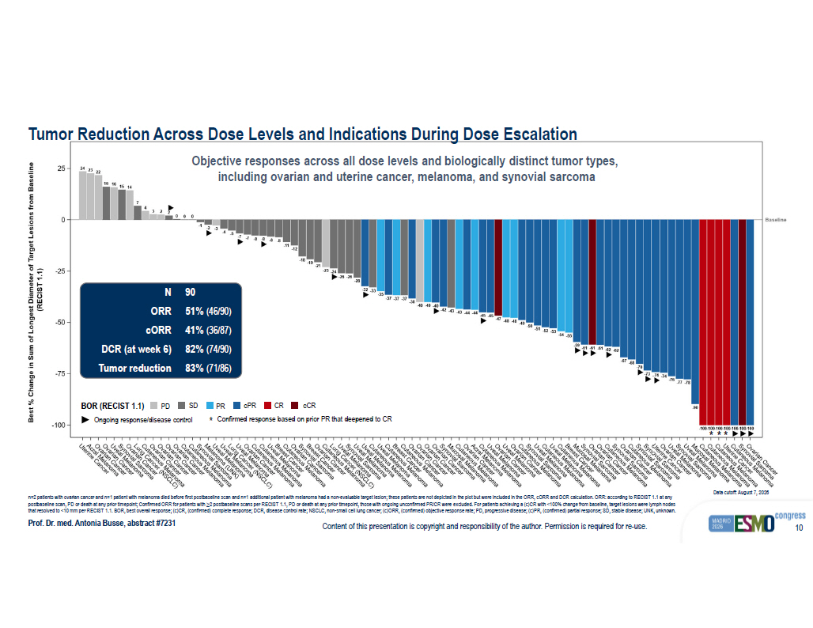
Content of this presentation is copyright and responsibility of the author. Permission is required for re - use. 10 'DWD?FXW ? RII ?? ???? ? ?? ? ?? ; ? D[LV ?? ,QGLFDWLRQ 3RSXODWLRQ ?? ,0$ ??? &' ? :DWHUIDOO 2QJRLQJ 3' 6' 35 F35 &5 F&5 %HVW?RYHUDOO?UHVSRQVH? ? 5(&,67? ? ? ? ? ?? ?? ?? ?? ?? ?? ?? ? ? ? ? ? ? ? ? ? ? ? ? ? ? ? ? ? ? ? ? ? ? ? ? ? ? ? ? ? ? ? ?? ? ?? ? ?? ? ?? ? ?? ? ?? ? ?? ? ?? ? ?? ? ?? ? ?? ? ?? ? ?? ? ?? ? ?? ? ?? ? ?? ? ?? ? ?? ? ?? ? ?? ? ?? ? ?? ? ?? ? ?? ? ?? ? ?? ? ?? ? ?? ? ?? ? ?? ? ?? ? ?? ? ?? ? ?? ? ?? ? ?? ? ?? ? ?? ? ?? ? ?? ? ?? ? ?? ? ?? ? ?? ? ?? ? ?? ? ?? ? ?? ? ?? ? ?? ? ?? ? ?? ? ??? ? ??? ? ??? ? ??? ? ??? ? ??? ? ??? ,QGLFDWLRQ ? ??? ? ?? ? ?? ? ?? ? ?? ? 5(&,67? ? ? ? ? %HVW? ?? &KDQJH?LQ?6XP?RI?/RQJHVW?'LDPHWHU?RI?7DUJHW?/HVLRQV?IURP?%DVHOLQH %DVHOLQH * * * Prof. Dr. med. Antonia Busse , abstract #7231 n=2 patients with ovarian cancer and n=1 patient with melanoma died before first postbaseline scan and n=1 additional patient wi th melanoma had a non - evaluable target lesion; these patients are not depicted in the plot but were included in the ORR, cORR and DCR calculation. ORR: according to RECIST 1.1 at any postbaseline scan, PD or death at any prior timepoint; Confirmed ORR for patients with ≥2 postbaseline scans per RECIST 1.1, PD or death at any prior timepoint, those with ongoing unconfirmed PR/CR were excluded. For patients achieving a (c)CR with <100 % c hange from baseline, target lesions were lymph nodes that resolved to <10 mm per RECIST 1.1. BOR, best overall response; (c)CR, (confirmed) complete response; DCR, disease contro l r ate; NSCLC, non - small cell lung cancer; (c)ORR, (confirmed) objective response rate; PD, progressive disease; (c)PR, (confirmed) partial response; SD, stable disease; UNK, unknown. Objective responses across all dose levels and biologically distinct tumor types, including ovarian and uterine cancer, melanoma, and synovial sarcoma 90 N 51% (46/90) ORR 41% (36/87) cORR 82% (74/90) DCR (at week 6) 83% (71/86) Tumor reduction Data cutoff: August 7, 2026 BOR (RECIST 1.1) PD Ongoing response/disease control SD PR cPR CR cCR * Confirmed response based on prior PR that deepened to CR Tumor Reduction Across Dose Levels and Indications During Dose Escalation

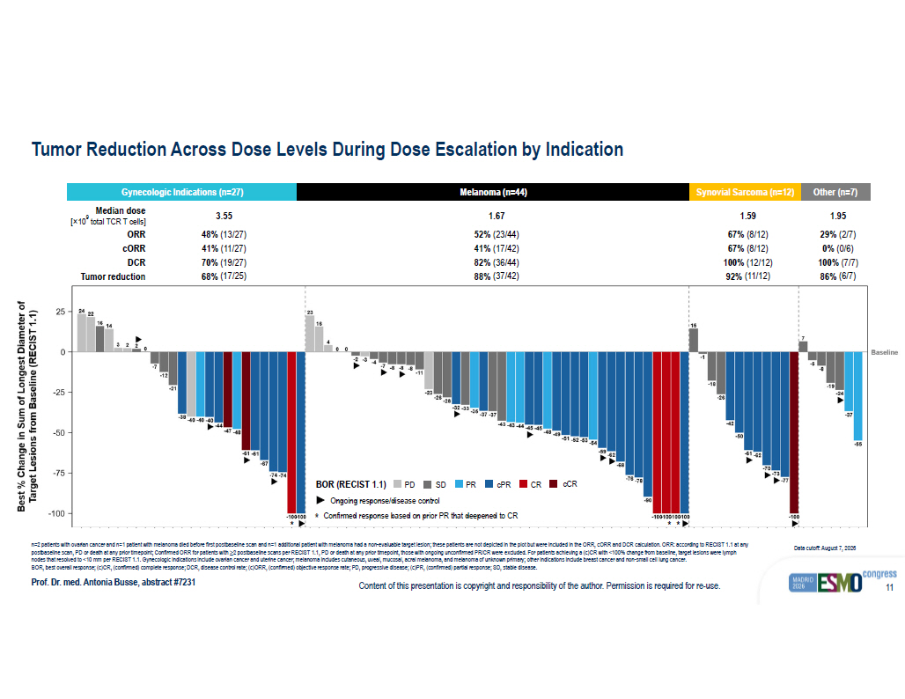
Content of this presentation is copyright and responsibility of the author. Permission is required for re - use. 11 'DWD?FXW ? RII ?? ???? ? ?? ? ??? 3DWLHQWV?DUH?RUGHUHG?E\?EHVW?SHUFHQWDJH?FKDQJH?ZLWKLQ?HDFK?VXEJURXS ? 6XEJURXS?RUGHU ?? ??????? 6HOHFWHG?VXEJURXS?EORFNV :DWHUIDOO?3ORW 2QJRLQJ 3' 6' 35 F35 &5 F&5 %HVW?RYHUDOO?UHVSRQVH? ? 5(&,67? ? ? ? ? ?? ?? ?? ?? ? ? ? ? ?? ?? ? ? ? ?? ? ? ? ? ?? ? ?? ? ?? ? ?? ? ?? ? ?? ? ?? ? ?? ? ?? ? ?? ? ?? ? ?? ? ?? ? ?? ? ??? ? ??? ? ? ? ? ? ? ? ? ? ? ? ? ? ? ? ?? ? ?? ? ?? ? ?? ? ?? ? ?? ? ?? ? ?? ? ?? ? ?? ? ?? ? ?? ? ?? ? ?? ? ?? ? ?? ? ?? ? ?? ? ?? ? ?? ? ?? ? ?? ? ?? ? ?? ? ?? ? ?? ? ??? ? ??? ? ??? ? ??? ? ? ? ?? ? ?? ? ?? ? ?? ? ?? ? ?? ? ?? ? ?? ? ?? ? ??? ? ? ? ? ? ?? ? ?? ? ?? ? ?? *\Q2QF 0HODQRPD 6\QRYLDO?6DUFRPD 2WKHU 'RVH?/HYHO ? ??? ? ?? ? ?? ? ?? ? ?? 7DUJHW?/HVLRQV?IURP?%DVHOLQH? ? 5(&,67? ? ? ? ? %HVW? ?? &KDQJH?LQ?6XP?RI?/RQJHVW?'LDPHWHU?RI %DVHOLQH * * * Tumor Reduction Across Dose Levels During Dose Escalation by Indication Prof. Dr. med. Antonia Busse , abstract #7231 Data cutoff: August 7, 2026 1.95 1.59 1.67 3.55 Median dose [ î 10 9 total TCR T cells] 29 % (2/ 7 ) 67% (8/12) 52 % (23/44) 48 % ( 13 / 27 ) ORR 0 % ( 0 / 6 ) 67% (8/12) 41 % ( 17 / 42 ) 41 % ( 11 / 27 ) cORR 100% (7/7) 100% (12/12) 8 2 % ( 36 / 44 ) 70% (1 9 / 27 ) DCR 86% (6/7) 92% (11/12) 8 8 % ( 37 / 42 ) 68% ( 17 / 25 ) Tumor reduction BOR (RECIST 1.1) PD Ongoing response/disease control SD PR cPR CR cCR * Confirmed response based on prior PR that deepened to CR Gynecologic Indications (n=27) Melanoma (n=44) Synovial Sarcoma (n=12) Other (n=7) n=2 patients with ovarian cancer and n=1 patient with melanoma died before first postbaseline scan and n=1 additional patient wi th melanoma had a non - evaluable target lesion; these patients are not depicted in the plot but were included in the ORR, cORR and DCR calculation. ORR: according to RECIST 1.1 at any postbaseline scan, PD or death at any prior timepoint; Confirmed ORR for patients with ≥2 postbaseline scans per RECIST 1.1, PD or death at any prior timepoint, those with ongoing unconfirmed PR/CR were excluded. For patients achieving a (c)CR with <100 % c hange from baseline, target lesions were lymph nodes that resolved to <10 mm per RECIST 1.1. Gynecologic indications include ovarian cancer and uterine cancer ; melanoma includes cutaneous , uveal , mucosal , acral melanoma , and melanoma of unknown primary ; other indications include breast cancer and non - small cell lung cancer . BOR, best overall response; (c)CR, (confirmed) complete response; DCR, disease control rate; (c)ORR, (confirmed) objective re spo nse rate; PD, progressive disease; (c)PR, (confirmed) partial response; SD, stable disease.

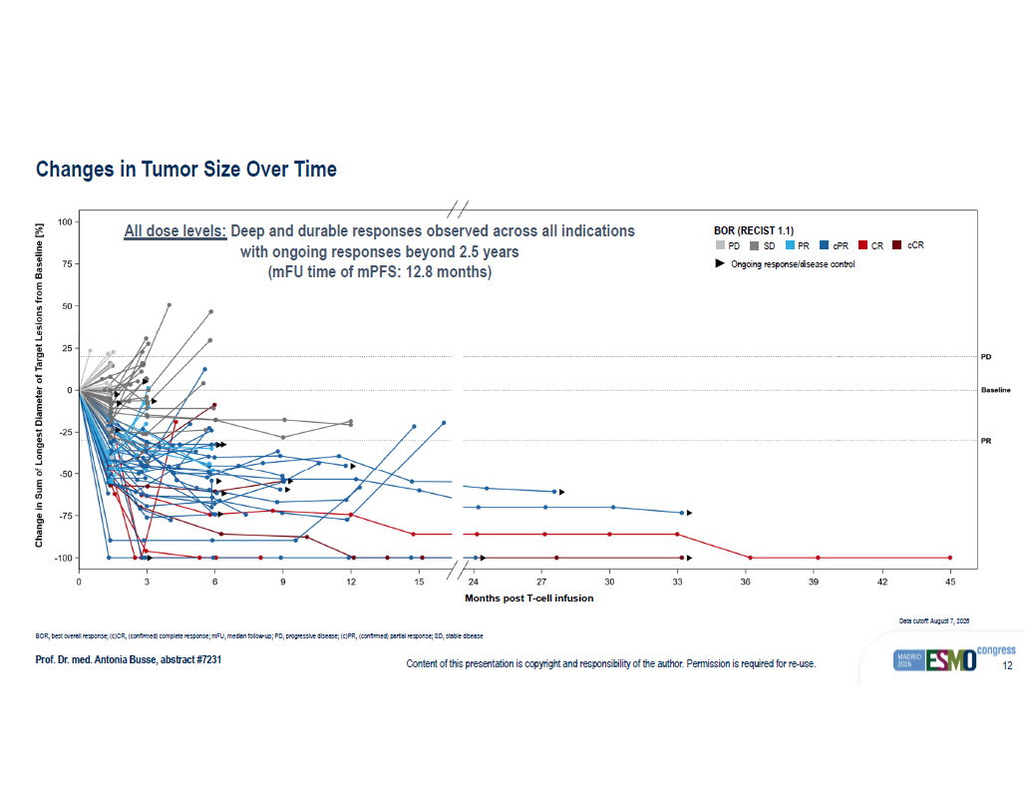
Content of this presentation is copyright and responsibility of the author. Permission is required for re - use. 12 Changes in Tumor Size Over Time Prof. Dr. med. Antonia Busse , abstract #7231 BOR, best overall response; (c)CR, (confirmed) complete response; mFU , median follow - up; PD, progressive disease; (c)PR, (confirmed) partial response; SD, stable disease Data cutoff: August 7, 2026 3' 3' %DVHOLQH %DVHOLQH 35 35 ? ? ? ? ?? ?? ?? ?? ?? ?? ?? ?? ?? ?? 0RQWKV?SRVW?7?FHOO?LQIXVLRQ ? ??? ? ?? ? ?? ? ?? ? ?? ?? ?? ??? &KDQJH?LQ?6XP?RI?/RQJHVW?'LDPHWHU?RI?7DUJHW?/HVLRQV?IURP?%DVHOLQH? >?@ 3' 6' 35 F35 &5 F&5 %HVW?RYHUDOO?UHVSRQVH? ? 5(&,67? ? ? ? ? 2QJRLQJ 6SLGHU 3RSXODWLRQ ?? (IILFDF\?$QDO\VLV?6HW? ?? ,0$ ??? &' ? 0DUNHUV ?? 'RW 'DWD?FXW ? RII ?? ???? ? ?? ? ?? All dose levels: Deep and durable responses observed across all indications with ongoing responses beyond 2.5 years ( mFU time of mPFS : 12.8 months ) BOR (RECIST 1.1) PD Ongoing response/disease control SD PR cPR CR cCR Months post T - cell infusion

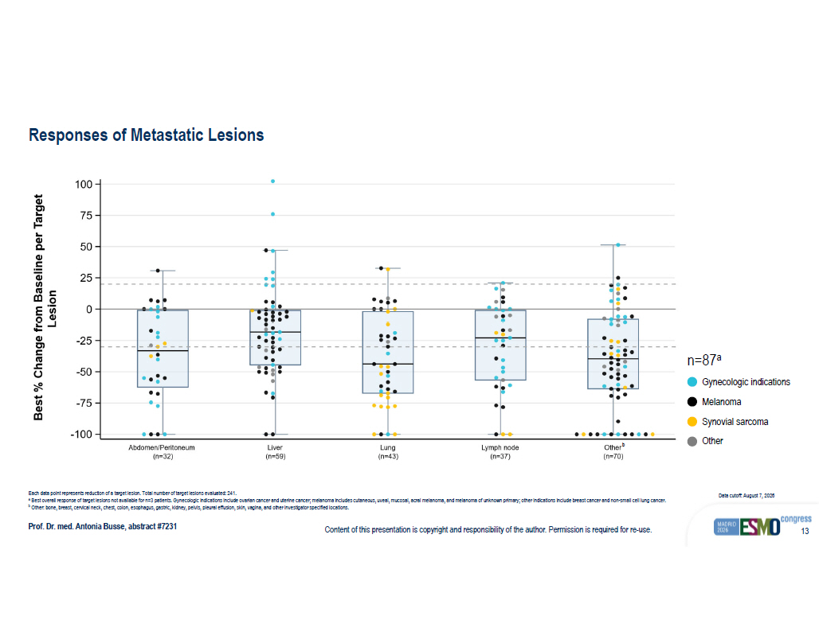
Content of this presentation is copyright and responsibility of the author. Permission is required for re - use. 13 Responses of Metastatic Lesions Prof. Dr. med. Antonia Busse , abstract #7231 Each data point represents reduction of a target lesion . Total number of target lesions evaluated : 241. a Best overall response of target lesions not available for n=3 patients . Gynecologic indications include ovarian cancer and uterine cancer ; melanoma includes cutaneous , uveal , mucosal , acral melanoma , and melanoma of unknown primary ; other indications include breast cancer and non - small cell lung cancer . b Other: bone , breast , cervical neck, chest , colon , esophagus , gastric , kidney , pelvis , pleural effusion , skin , vagina , and other investigator specified locations . Data cutoff: August 7, 2026 Melanoma Gynecologic indications Synovial sarcoma Other n=87 a ? ??? ? ?? ? ?? ? ?? ? ?? ?? ?? ??? /HVLRQ %HVW? ?? &KDQJH?IURP?%DVHOLQH?SHU?7DUJHW ? Q ?? ? $EGRPHQ ? 3HULWRQHXP ? Q ?? ? /LYHU ? Q ?? ? /XQJ ? Q ?? ? /\PSK?QRGH ? Q ?? ? 2WKHU 2WKHUV 6\QRYLDO?6DUFRPD *\Q2QF 0HODQRPD ,QGLFDWLRQ %HVW? ?? &KDQJH?IURP?%DVHOLQH?SHU?7DUJHW?/HVLRQ ($6 ?? ??? SDWLHQWV ?? ???? WDUJHW?OHVLRQV %R[SORW?V\PEROV ?? FRORUHG?GRW? ? RQH?WDUJHW?OHVLRQ? ? FRORU?LQGLFDWHV?PDLQ?LQGLFDWLRQ?JURXS ? ?? ER[? ? LQWHUTXDUWLOH?UDQJH? ? ?? WK ? ?? WK?SHUFHQWLOH ? ?? OLQH?LQVLGH?ER[? ? PHGLDQ ?? ZKLVNHUV? ? PRVW?H[WUHPH?QRQ ? RXWO\LQJ?YDOXHV ? 5HIHUHQFH?OLQHV ?? GDVKHG?JUH\? ?? ?? ?? DQG? ? ?? ? ?? VROLG?JUH\? ? ? ??? 9DOXHV?LQ?SDUHQWKHVHV?EHORZ?HDFK?ORFDWLRQ?DUH?WKH?QXPEHU?RI?WDUJHW?OHVLRQV?FRQWULEXWLQJ?WR?WKDW?ER[SORW ? /RFDWLRQV?JURXSHG?LQWR?2WKHU ?? %RQH ?? %UHDVW ?? &HUYLFDO?1HFN ?? &KHVW ?? &RORQ ?? (VRSKDJXV ?? *DVWULF ?? .LGQH\ ?? 2WKHU ?? 3HOYLV ?? 3OHXUDO?(IIXVLRQ ?? 6NLQ ?? 9DJLQD %HVW?FKDQJH?LV?WKH?PLQLPXP?SRVW ? EDVHOLQH?SHUFHQW?FKDQJH?IURP?EDVHOLQH?DPRQJ?$1/ ?? )/
<
? DVVHVVPHQWV ?? 'DWD?FXW ? RII ?? ???? ? ?? ? ?? ($6?SDWLHQWV?QRW?UHSUHVHQWHG?LQ?WKLV?ILJXUH? ? 1 ? ??? ??? ? ?? ? ??? ? 1R?SRVW ? EDVHOLQH?WDUJHW ? OHVLRQ?6/'?DVVHVVPHQW ?? ??? ? ?? ? ??? ? 1R?SRVW ? EDVHOLQH?WDUJHW ? OHVLRQ?6/'?DVVHVVPHQW ?? ??? ? ?? ? ??? ? 1R?SRVW ? EDVHOLQH WDUJHW ? OHVLRQ?6/'?DVVHVVPHQW b

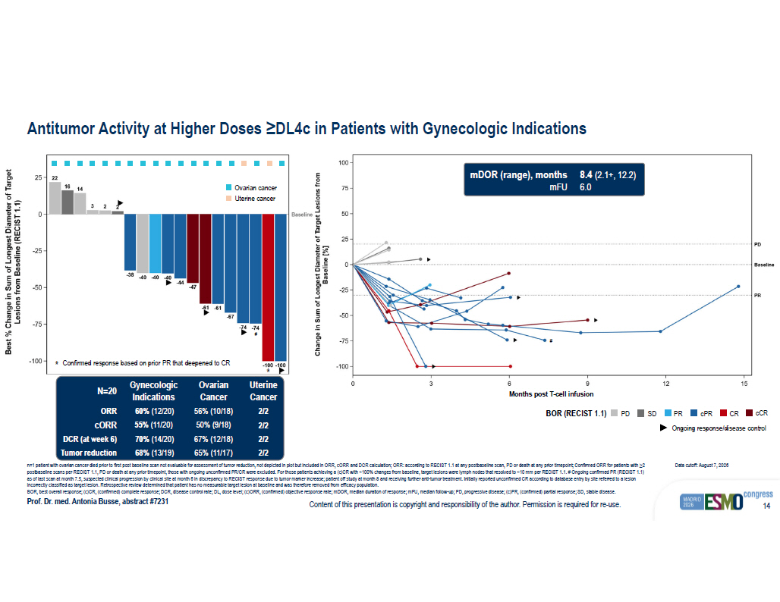
Content of this presentation is copyright and responsibility of the author. Permission is required for re - use. 14 ? ? ? ? ?? ?? 0RQWKV?SRVW?7?FHOO?LQIXVLRQ ? ??? ? ?? ? ?? ? ?? ? ?? ?? ?? ??? %DVHOLQH? >?@ &KDQJH?LQ?6XP?RI?/RQJHVW?'LDPHWHU?RI?7DUJHW?/HVLRQV?IURP 3' %DVHOLQH 35 3' 6' 35 F35 &5 F&5 %HVW?RYHUDOO?UHVSRQVH? ? 5(&,67? ? ? ? ? 2QJRLQJ 6SLGHU 3RSXODWLRQ ?? (IILFDF\?$QDO\VLV?6HW? ?? *\Q2QF?%XQGOH? ?? ,0$ ??? &' ?? LQ?'/ ? F?RU?KLJKHU 0DUNHUV ?? 'RW 'DWD?FXW ? RII ?? ???? ? ?? ? ?? 'DWD?FXW ? RII ?? ???? ? ?? ? ?? ; ? D[LV ?? ,QGLFDWLRQ 3RSXODWLRQ ?? *\Q2QF?%XQGOH? ?? ,0$ ??? &' ?? LQ?'/ ? F?RU?KLJKHU :DWHUIDOO 2QJRLQJ 3' 6' 35 F35 &5 F&5 %HVW?RYHUDOO?UHVSRQVH? ? 5(&,67? ? ? ? ? ?? ?? ?? ? ? ? ? ?? ? ?? ? ?? ? ?? ? ?? ? ?? ? ?? ? ?? ? ?? ? ?? ? ?? ? ??? ? ??? ,QGLFDWLRQ ? ??? ? ?? ? ?? ? ?? ? ?? /HVLRQV?IURP?%DVHOLQH? ? 5(&,67? ? ? ? ? %HVW? ?? &KDQJH?LQ?6XP?RI?/RQJHVW?'LDPHWHU?RI?7DUJHW %DVHOLQH Antitumor Activity at Higher Doses ≥DL4c in Patients with Gynecologic Indications Prof. Dr. med. Antonia Busse , abstract #7231 n=1 patient with ovarian cancer died prior to first post baseline scan not evaluable for assessment of tumor reduction, not d epi cted in plot but included in ORR, cORR and DCR calculation; ORR: according to RECIST 1.1 at any postbaseline scan, PD or death at any prior timepoint; Confirmed ORR f or patients with ≥2 postbaseline scans per RECIST 1.1, PD or death at any prior timepoint, those with ongoing unconfirmed PR/CR were excluded. Fo r t hose patients achieving a (c)CR with <100% changes from baseline, target lesions were lymph nodes that resolved to <10 mm per RE CIST 1.1. # Ongoing confirmed PR (RECIST 1.1) as of last scan at month 7.5, suspected clinical progression by clinical site at month 6 in discrepancy to RECIST response du e t o tumor marker increase; patient off study at month 8 and receiving further anti - tumor treatment. Initially reported unconfirmed CR according to database entry by site referred to a lesion incorrectly classified as target lesion. Retrospective review determined that patient has no measurable target lesion at base lin e and was therefore removed from efficacy population. BOR, best overall response; (c)CR, (confirmed) complete response; DCR, disease control rate; DL, dose level; (c)ORR, (confirm ed) objective response rate; mDOR , median duration of response; mFU , median follow - up; PD, progressive disease; (c)PR, (confirmed) partial response; SD, stable disease. Data cutoff: August 7, 2026 BOR (RECIST 1.1) PD Ongoing response/disease control SD PR cPR CR cCR * Confirmed response based on prior PR that deepened to CR * Ovarian cancer Uterine cancer Uterine Cancer Ovarian Cancer Gynecologic Indications N=20 2/2 56% (10/18) 60% (12/20) ORR 2/2 50% (9/18) 55% (11/20) cORR 2/2 67% (12/18) 70% (14/20) DCR (at week 6) 2/2 65% (11/17) 68% (13/19) Tumor reduction # Months post T - cell infusion 8.4 (2.1+, 12.2) 6.0 mDOR (range), months mFU #

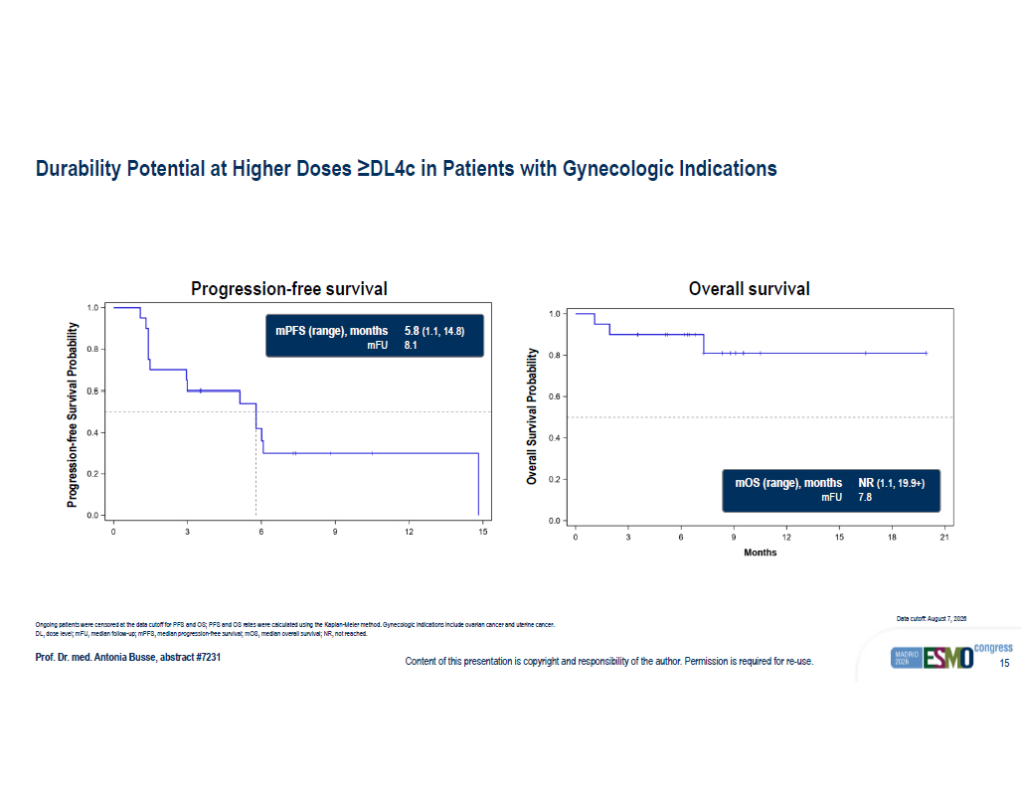
Content of this presentation is copyright and responsibility of the author. Permission is required for re - use. 15 .DSODQ ? 0HLHU?HVWLPDWHV ?? FHQVRULQJ?LQGLFDWHG?E\?SOXV?VLJQV ? 'DWD?FXW ? RII ?? ???? ? ?? ? ?? 3RSXODWLRQ ?? *\Q2QF?%XQGOH? ?? ,0$ ??? &' ?? LQ?'/ ? F?RU?KLJKHU?LQ?($6 3URJUHVVLRQ ? )UHH?6XUYLYDO ?? ?? ? ? ? ? 1XPEHU?DW?ULVN RU?KLJKHU *\Q2QF?%XQGOH? ?? ,0$ ??? &' ?? LQ?'/ ? F ? ? ? ? ?? ?? 0RQWKV ? ? ? ? ? ? ? ? ? ? ? ? ? ? ? ? ? ? 6XUYLYDO?SUREDELOLW\ *\Q2QF?%XQGOH? ?? ,0$ ??? &' ?? LQ?'/ ? F?RU?KLJKHU Durability Potential at Higher Doses ≥DL4c in Patients with Gynecologic Indications Prof. Dr. med. Antonia Busse , abstract #7231 Ongoing patients were censored at the data cutoff for PFS and OS; PFS and OS rates were calculated using the Kaplan - Meier method . Gynecologic indications include ovarian cancer and uterine cancer . DL, dose level; mFU , median follow - up; mPFS , median progression - free survival; mOS , median overall survival; NR, not reached. Data cutoff: August 7, 2026 Progression - free survival Overall survival 5.8 (1.1, 14.8) 8.1 mPFS (range), months mFU NR (1.1, 19.9+) 7.8 mOS (range), months mFU Progression - free Survival Probability Overall Survival Probability

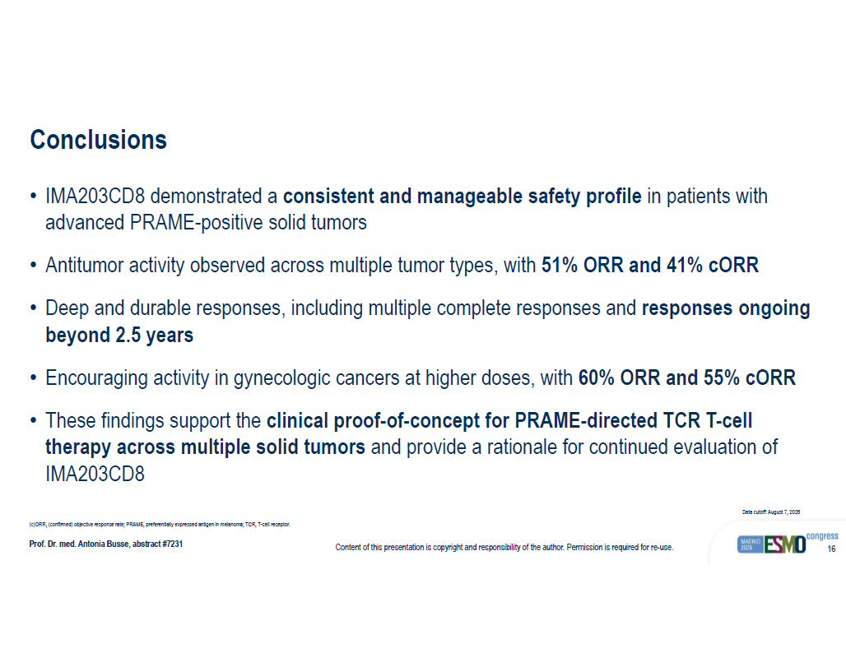
Content of this presentation is copyright and responsibility of the author. Permission is required for re - use. 16 Conclusions Prof. Dr. med. Antonia Busse , abstract #7231 • IMA203CD8 demonstrated a consistent and manageable safety profile in patients with advanced PRAME - positive solid tumors • Antitumor activity observed across multiple tumor types , with 51% ORR and 41% cORR • Deep and durable responses , including multiple complete responses and responses ongoing beyond 2.5 years • Encouraging activity in gynecologic cancers at higher doses , with 60% ORR and 55% cORR • These findings support the clinical proof - of - concept for PRAME - directed TCR T - cell therapy across multiple solid tumors and provide a rationale for continued evaluation of IMA203CD8 (c)ORR, (confirmed) objective response rate; PRAME, preferentially expressed antigen in melanoma; TCR, T - cell receptor. Data cutoff: August 7, 2026

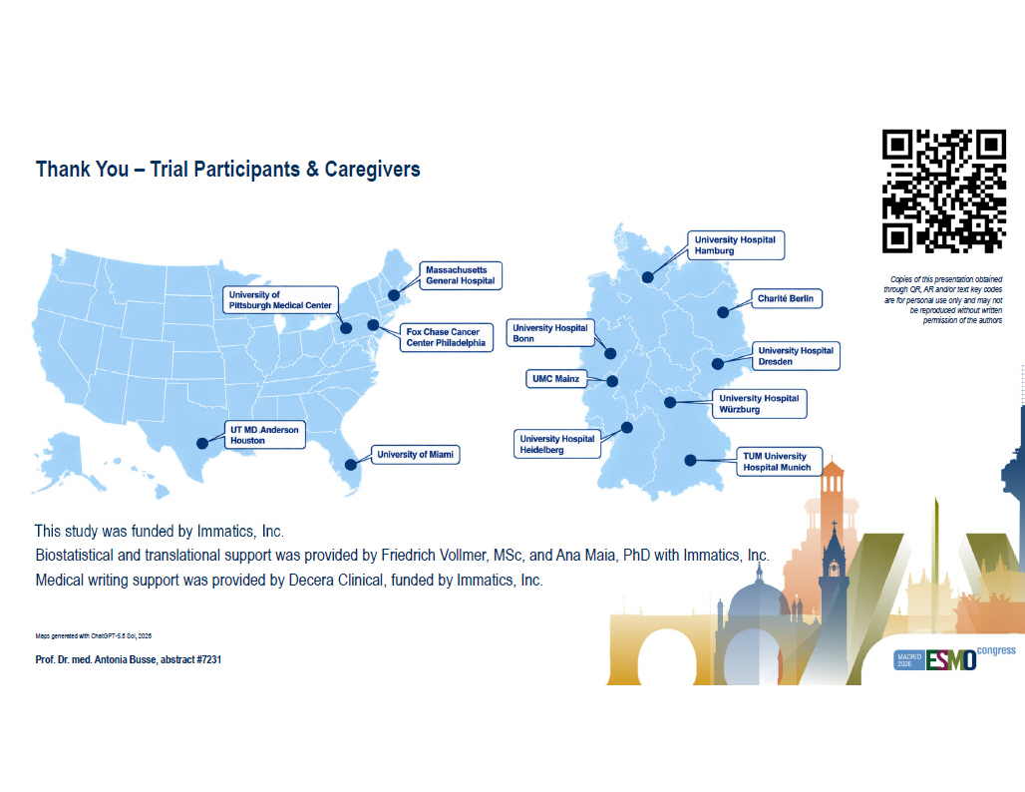
Thank You – Trial Participants & Caregivers Prof. Dr. med. Antonia Busse , abstract #7231 This study was funded by Immatics , Inc. Biostatistical and translational support was provided by Friedrich Vollmer, MSc , and Ana Maia, PhD with Immatics , Inc. Medical writing support was provided by Decera Clinical, funded by Immatics , Inc. Maps generated with ChatGPT - 5.6 Sol, 2026 Copies of this presentation obtained through QR, AR and/or text key codes are for personal use only and may not be reproduced without written permission of the authors


Appendix

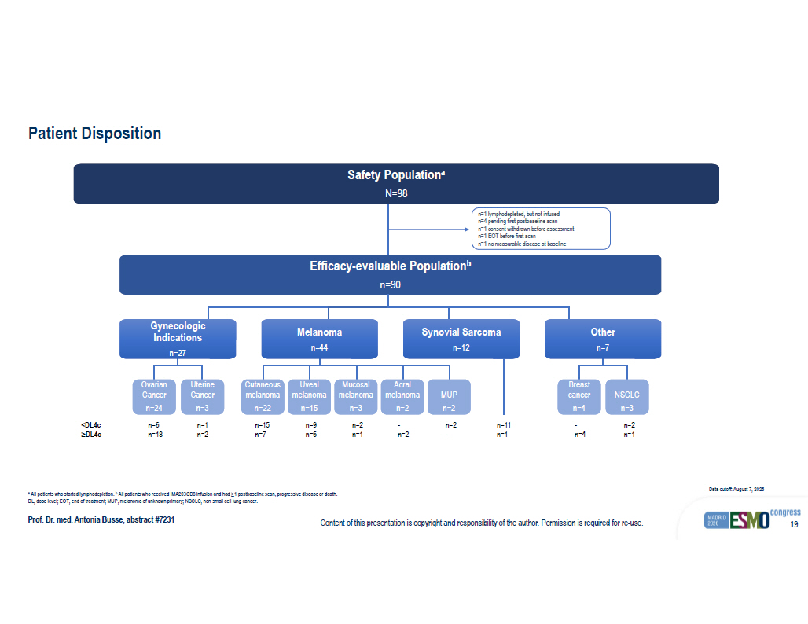
Content of this presentation is copyright and responsibility of the author. Permission is required for re - use. 19 Patient Disposition Prof. Dr. med. Antonia Busse , abstract #7231 a All patients who started lymphodepletion . b All patients who received IMA203CD8 infusion and had ≥1 postbaseline scan, progressive disease or death. DL, dose level; EOT, end of treatment; MUP, melanoma of unknown primary; NSCLC, non - small cell lung cancer . Data cutoff: August 7, 2026 Safety Population a N=98 Efficacy - evaluable Population b n=90 Gynecologic Indications n=27 Melanoma n=44 Synovial Sarcoma n=12 n=1 lymphodepleted, but not infused n=4 pending first postbaseline scan n=1 consent withdrawn before assessment n=1 EOT before first scan n=1 no measurable disease at baseline <DL4c ≥DL4c Ovarian Cancer n=24 Uterine Cancer n=3 Cutaneous melanoma n=22 MUP n=2 n=6 n=18 n=1 n=2 n=15 n=7 n=9 n=6 n=2 n=1 - n=2 n=2 - - n=4 n=2 n=1 Uveal melanoma n=15 Mucosal melanoma n=3 Acral melanoma n=2 Other n=7 Breast cancer n=4 NSCLC n=3 n=11 n=1

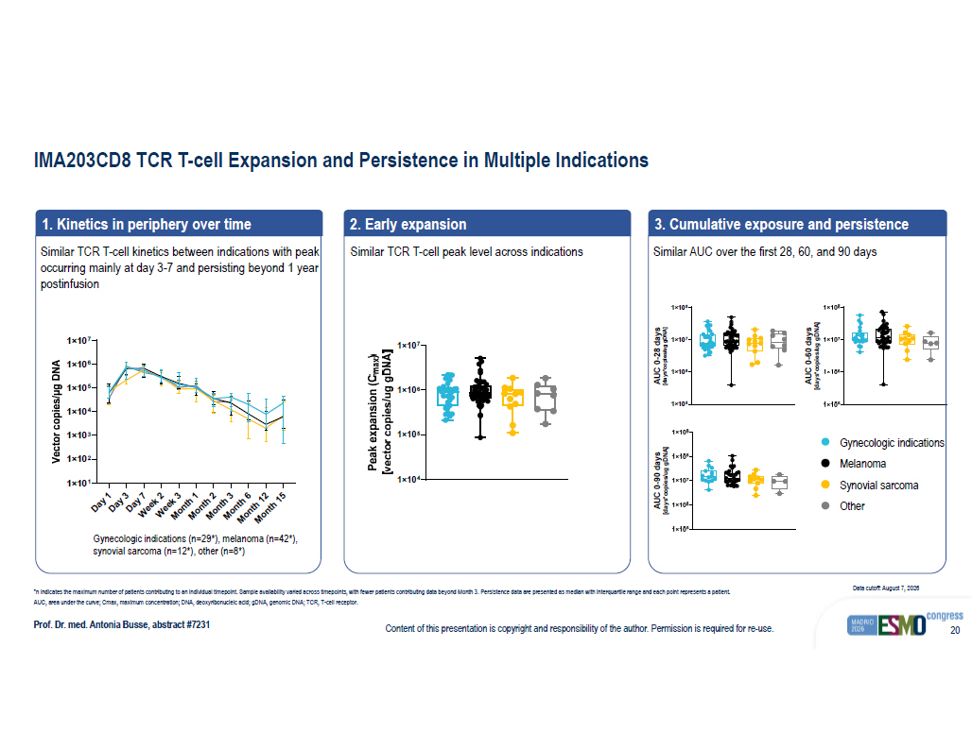
Content of this presentation is copyright and responsibility of the author. Permission is required for re - use. 20 IMA203CD8 TCR T - cell Expansion and Persistence in Multiple Indications Prof. Dr. med. Antonia Busse , abstract #7231 *n indicates the maximum number of patients contributing to an individual timepoint . Sample availability varied across timepoints , with fewer patients contributing data beyond Month 3. Persistence data are presented as median with interquartile range and each point represents a patient. AUC, area under the curve ; Cmax , maximum concentration ; DNA, deoxyribonucleic acid ; gDNA , genomic DNA; TCR, T - cell receptor . Data cutoff: August 7, 2026 1. Kinetics in periphery over time Similar TCR T - cell kinetics between indications with peak occurring mainly at day 3 - 7 and persisting beyond 1 year postinfusion Gynecologic indications (n=29*), melanoma (n=42*), synovial sarcoma (n=12*), other (n=8*) 2. Early expansion Similar TCR T - cell peak level across indications 3. Cumulative exposure and persistence Melanoma Gynecologic indications Synovial sarcoma Other Similar AUC over the first 28, 60, and 90 days

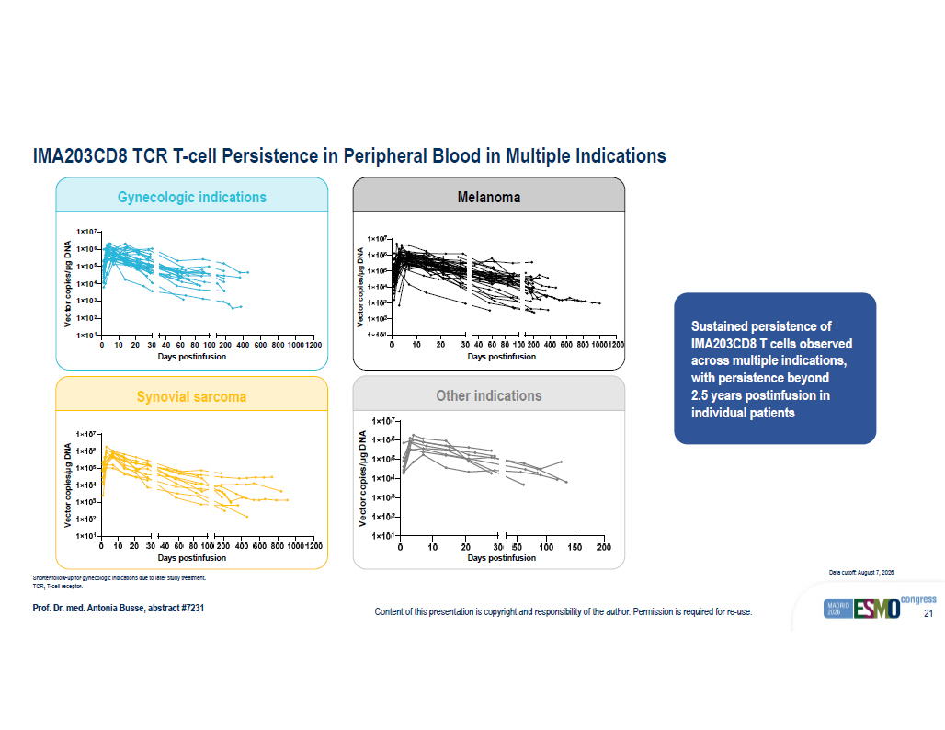
Content of this presentation is copyright and responsibility of the author. Permission is required for re - use. 21 IMA203CD8 TCR T - cell Persistence in Peripheral Blood in Multiple Indications Prof. Dr. med. Antonia Busse , abstract #7231 Shorter follow - up for gynecologic indications due to later study treatment. TCR, T - cell receptor . Data cutoff: August 7, 2026 Sustained persistence of IMA203CD8 T cells observed across multiple indications, with persistence beyond 2.5 years postinfusion in individual patients Other indications 0 10 20 30 1×10 1 1×10 2 1×10 3 1×10 4 1×10 5 1×10 6 1×10 7 40 60 80 100200 400 600 80010001200 Days post-infusion V e c t o r c o p i e s / µ g D N A Gynecologic indications Melanoma Synovial sarcoma Days postinfusion Days postinfusion Days postinfusion Days postinfusion

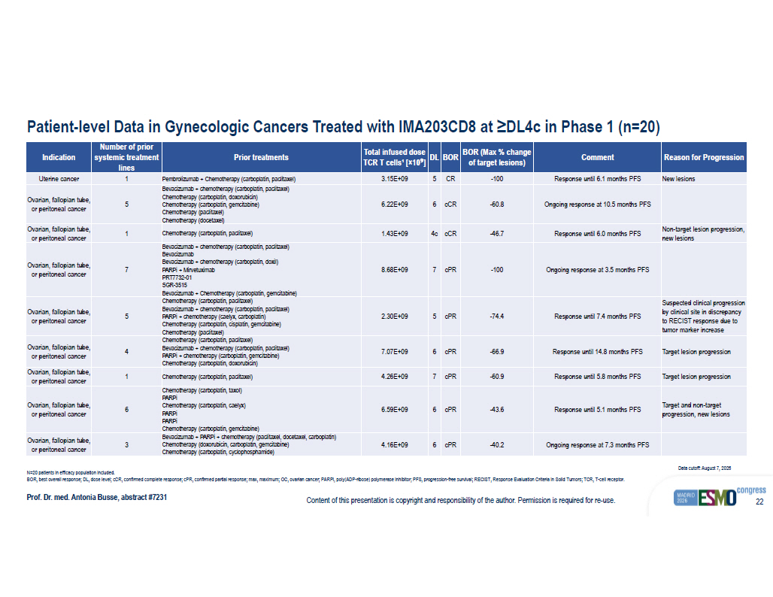
Content of this presentation is copyright and responsibility of the author. Permission is required for re - use. 22 Patient - level Data in Gynecologic Cancers Treated with IMA203CD8 at ≥DL4c in Phase 1 (n=20) Prof. Dr. med. Antonia Busse , abstract #7231 N=20 patients in efficacy population included. BOR, best overall response ; DL, dose level ; cCR , confirmed complete response ; cPR , confirmed partial response ; max , maximum; OC, ovarian cancer ; PARPi , poly (ADP - ribose) polymerase inhibitor ; PFS, progression - free survival ; RECIST, Response Evaluation Criteria in Solid Tumors; TCR, T - cell receptor . Data cutoff: August 7, 2026 Reason for Progression Comment BOR (Max % change of target lesions) BOR DL Total infused dose TCR T cells¹ [ × 10 ⁹ ] Prior treatments Number of prior systemic treatment lines Indication New lesions Response until 6.1 months PFS - 100 CR 5 3.15E+09 Pembrolizumab + Chemotherapy (carboplatin, paclitaxel) 1 Uterine cancer Ongoing response at 10.5 months PFS - 60.8 cCR 6 6.22E+09 Bevacizumab + chemotherapy (carboplatin, paclitaxel) Chemotherapy (carboplatin, doxorubicin) Chemotherapy (carboplatin, gemcitabine) Chemotherapy (paclitaxel) Chemotherapy (docetaxel) 5 Ovarian, fallopian tube, or peritoneal cancer Non - target lesion progression, new lesions Response until 6.0 months PFS - 46.7 cCR 4c 1.43E+09 Chemotherapy (carboplatin, paclitaxel) 1 Ovarian, fallopian tube, or peritoneal cancer Ongoing response at 3.5 months PFS - 100 cPR 7 8.68E+09 Bevacizumab + chemotherapy (carboplatin, paclitaxel) Bevacizumab Bevacizumab + chemotherapy (carboplatin, doxil) PARPi + Mirvetuximab PRT7732 - 01 SGR - 3515 Bevacizumab + Chemotherapy (carboplatin, gemcitabine) 7 Ovarian, fallopian tube, or peritoneal cancer Suspected clinical progression by clinical site in discrepancy to RECIST response due to tumor marker increase Response until 7.4 months PFS - 74.4 cPR 5 2.30E+09 Chemotherapy (carboplatin, paclitaxel) Bevacizumab + chemotherapy (carboplatin, paclitaxel) PARPi + chemotherapy (caelyx, carboplatin) Chemotherapy (carboplatin, cisplatin, gemcitabine) Chemotherapy (paclitaxel) 5 Ovarian, fallopian tube, or peritoneal cancer Target lesion progression Response until 14.8 months PFS - 66.9 cPR 6 7.07E+09 Chemotherapy (carboplatin, paclitaxel) Bevacizumab + chemotherapy (carboplatin, paclitaxel) PARPi + chemotherapy (carboplatin, gemcitabine) Chemotherapy (carboplatin, doxorubicin) 4 Ovarian, fallopian tube, or peritoneal cancer Target lesion progression Response until 5.8 months PFS - 60.9 cPR 7 4.26E+09 Chemotherapy ( carboplatin , paclitaxel ) 1 Ovarian, fallopian tube, or peritoneal cancer Target and non - target progression, new lesions Response until 5.1 months PFS - 43.6 cPR 6 6.59E+09 Chemotherapy (carboplatin, taxol) PARPi Chemotherapy (carboplatin, caelyx) PARPi PARPi Chemotherapy (carboplatin, gemcitabine) 6 Ovarian, fallopian tube, or peritoneal cancer Ongoing response at 7.3 months PFS - 40.2 cPR 6 4.16E+09 Bevacizumab + PARPi + chemotherapy (paclitaxel, docetaxel, carboplatin) Chemotherapy (doxorubicin, carboplatin, gemcitabine) Chemotherapy (carboplatin, cyclophosphamide) 3 Ovarian, fallopian tube, or peritoneal cancer

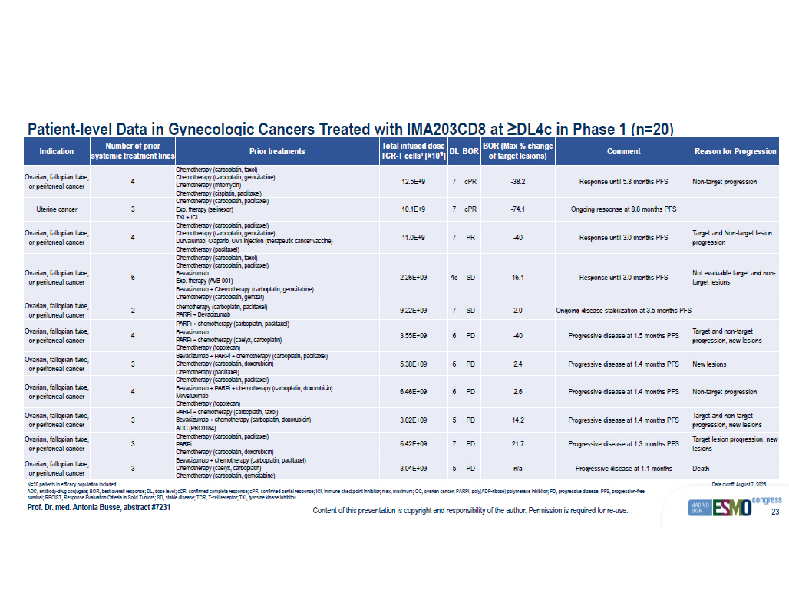
Content of this presentation is copyright and responsibility of the author. Permission is required for re - use. 23 Patient - level Data in Gynecologic Cancers Treated with IMA203CD8 at ≥DL4c in Phase 1 (n=20) Prof. Dr. med. Antonia Busse , abstract #7231 N=20 patients in efficacy population included . ADC, antibody - drug conjugate ; BOR, best overall response ; DL, dose level ; cCR , confirmed complete response ; cPR , confirmed partial response ; ICI, immune checkpoint inhibitor ; max , maximum; OC, ovarian cancer ; PARPi , poly (ADP - ribose) polymerase inhibitor ; PD, progressive disease ; PFS, progression - free survival ; RECIST, Response Evaluation Criteria in Solid Tumors; SD, stable disease ; TCR, T - cell receptor ; TKI, tyrosine kinase inhibitor . Data cutoff: August 7, 2026 Reason for Progression Comment BOR (Max % change of target lesions) BOR DL Total infused dose TCR - T cells¹ [ × 10 ⁹ ] Prior treatments Number of prior systemic treatment lines Indication Non - target progression Response until 5.8 months PFS - 38.2 cPR 7 12.5E+9 Chemotherapy (carboplatin, taxol) Chemotherapy (carboplatin, gemcitabine) Chemotherapy (mitomycin) Chemotherapy (cisplatin, paclitaxel) 4 Ovarian, fallopian tube, or peritoneal cancer Ongoing response at 8.8 months PFS - 74.1 cPR 7 10.1E+9 Chemotherapy (carboplatin, paclitaxel) Exp. therapy (selinexor) TKI + ICI 3 Uterine cancer Target and Non - target lesion progression Response until 3.0 months PFS - 40 PR 7 11.0E+9 Chemotherapy (carboplatin, paclitaxel) Chemotherapy (carboplatin, gemcitabine) Durvalumab, Olaparib, UV1 injection (therapeutic cancer vaccine) Chemotherapy (paclitaxel) 4 Ovarian, fallopian tube, or peritoneal cancer Not evaluable target and non - target lesions Response until 3.0 months PFS 16.1 SD 4c 2.26E+09 Chemotherapy (carboplatin, taxol) Chemotherapy (carboplatin, paclitaxel) Bevacizumab Exp. therapy (AVB - 001) Bevacizumab + Chemotherapy (carboplatin, gemcitabine) Chemotherapy (carboplatin, gemzar) 6 Ovarian, fallopian tube, or peritoneal cancer Ongoing disease stabilization at 3.5 months PFS 2.0 SD 7 9.22E+09 chemotherapy (carboplatin, paclitaxel) PARPi + Bevacizumab 2 Ovarian, fallopian tube, or peritoneal cancer Target and non - target progression, new lesions Progressive disease at 1.5 months PFS - 40 PD 6 3.55E+09 PARPi + chemotherapy (carboplatin, paclitaxel) Bevacizumab PARPi + chemotherapy (caelyx, carboplatin) Chemotherapy (topotecan) 4 Ovarian, fallopian tube, or peritoneal cancer New lesions Progressive disease at 1.4 months PFS 2.4 PD 6 5.38E+09 Bevacizumab + PARPi + chemotherapy (carboplatin, paclitaxel) Chemotherapy (carboplatin, doxorubicin) Chemotherapy (paclitaxel) 3 Ovarian, fallopian tube, or peritoneal cancer Non - target progression Progressive disease at 1.4 months PFS 2.6 PD 6 6.46E+09 Chemotherapy (carboplatin, paclitaxel) Bevacizumab + PARPi + chemotherapy (carboplatin, doxorubicin) Mirvetuximab Chemotherapy (topotecan) 4 Ovarian, fallopian tube, or peritoneal cancer Target and non - target progression , new lesions Progressive disease at 1.4 months PFS 14.2 PD 5 3.02E+09 PARPi + chemotherapy (carboplatin, taxol) Bevacizumab + chemotherapy (carboplatin, doxorubicin) ADC (PRO1184) 3 Ovarian, fallopian tube, or peritoneal cancer Target lesion progression, new lesions Progressive disease at 1.3 months PFS 21.7 PD 7 6.42E+09 Chemotherapy (carboplatin, paclitaxel) PARPi Chemotherapy (carboplatin, doxorubicin) 3 Ovarian, fallopian tube, or peritoneal cancer Death Progressive disease at 1.1 months n/a PD 5 3.04E+09 Bevacizumab + chemotherapy (carboplatin, paclitaxel) Chemotherapy (caelyx, carboplatin) Chemotherapy (carboplatin, gemcitabine) 3 Ovarian, fallopian tube, or peritoneal cancer

